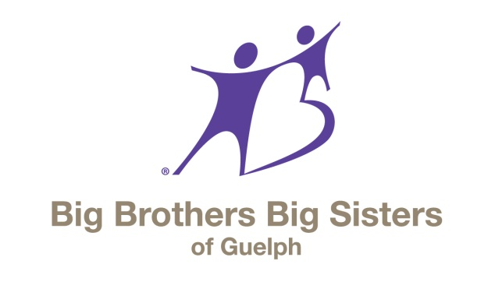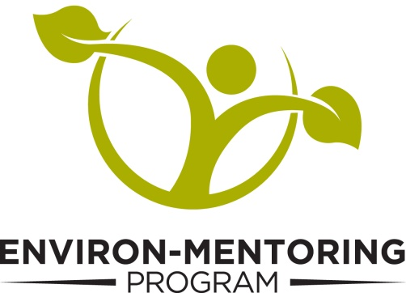
2015 Final Report
Prepared for:

Through the support of the Ontario Wildlife Foundation, the youth in the Environ-Mentoring Program have explored their surroundings and the positive impact they can have on the environment. In 2015 they learned about natural selection, water ecology, wetland biodiversity and winter wildlife; toured the local dams and cave systems; went canoeing and snowshoeing to investigate the surroundings; and learned how to navigate using GPS technology and make winter bird feeders.
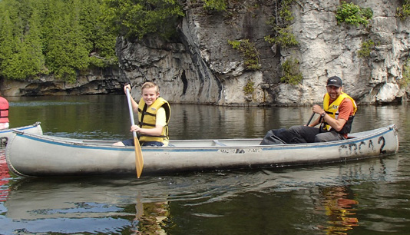
Program Evaluation
Effectiveness of the program was measured on the following:
- The number of youth attending as compared to the number that enroll (to gauge initial interest)
- The number of children that wish to attend multiple sessions (to gauge long term interest)
- Whether the attending children feel the classes are valuable (to gauge effectiveness)
- The volunteers' assessment of the program's value for the attending children (to gauge program relevancy and improvements for the future)
In terms of program effectiveness, our collected data has shown very positive trends:
1. Out of all of the youth initially enrolled in the Environ-Mentoring Program, 98.6% attended the sessions, indicating an extremely positive response to attendance. This leads us to conclude that the initial interest from the local youth is high enough to engage them in the programming.
2. 85.1% of the responding youth expressed that they would like to return for additional sessions in the future. This indicates that long-term interest in the program is also high, and that participating youth would continue to attend multiple sessions.
3. 88.9% of the youth surveyed relayed information about the material they discussed and heard during the day. This indicates that the children are effectively learning about their surroundings and their place in them.
4. The responses from the volunteer mentors were overwhelmingly positive, with all of them praising the relevance of the GRCA programming. In addition, all responses indicated a desire to return for further sessions and different program areas.
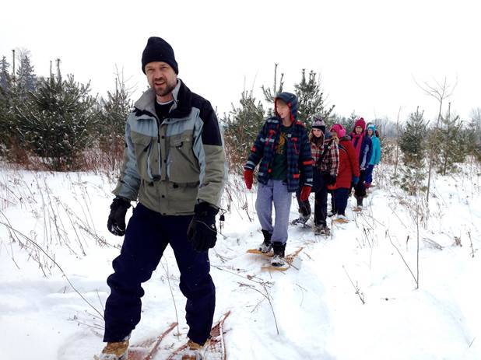
Testimonials from Big Brothers/Sisters
“The girls aged 9 to 16 group attended the GPS navigation workshop and they really enjoyed themselves, along with myself and another big. We got to explore the Guelph lake grounds with the guide, as well as on our own when we had to place the geocaches for the other groups to find. I would highly recommend partnering up with them again next year and we will definitely be attending more sessions!” – April, Big Sister
“I am a big in the 5-8 group. Our kids loved both of the programs that we went to. I was at the pond one and the person from GRCA was great with the kids and had explanations that met their level. I would recommend doing it again if we had the opportunity.” – Brad, Big Brother
“We really enjoyed the dam presentation; we found it really interesting, and well presented, and interacting with the snakes was a real highlight for everyone. We would definitely participate in other programs, should they come up at a time when we are able to attend. Thank you for offering these programs to the Big and Little Brothers/Sisters.” – Elayne, Big Sister

I hope this report is satisfactory. Once again, Big Brothers Big Sisters of Guelph would like to thank OWF for your support of our Environ-Mentoring Program. 2015 was a fantastic year for the program, the first full year of Environ-Mentoring. Thanks to your backing, we were able to spread the word of the program’s success and are running it again for all of 2016, with a formal program contract in place through the GRCA. Your belief in BBBSG and the youth we serve has meant so much to us, them and their families.
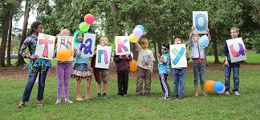
Respectfully submitted,
Darryl Blake, Development Writer
Big Brothers Big Sisters of Guelph

